
School: ............................................................................................................. Campus: ....................................................... Academic Year: ...................... Subject Name: ........................................................... Subject Code: ..........................
Semester: ............... Program: ........................................ Branch: ......................... Specialization: .......................... Date: .....................................
(Learning by Doing and Discovery)
* Coding Phase: Pseudo Code / Flow Chart / Algorithm
Introduction to Blockchain
Blockchain is a decentralized, peer-to-peer network that acts as a secure, shared ledger. It stores records in a way that is cryptographically protected, append-only (you can add but not remove data), highly resistant to alteration, and updated only when network participants reach an agreement (consensus).

Key Characteristics of Blockchain:
- Decentralization – No single central authority controls the system.
- Immutability – Once recorded, data cannot be easily changed.
- Transparency – Transactions are visible to all participants in the network.
- Smart Contracts – Code that runs automatically when certain conditions are met.
- Security – Strong cryptographic methods protect data from unauthorized access.
- Consensus Algorithms – Rules that allow nodes to agree on the state of the ledger.
- Distributed Ledger – A shared copy of the database is maintained by multiple participants.
- Privacy & Anonymity – Identities can remain hidden while ensuring transaction integrity

Blockchain Architectural Components:

- Nodes – Devices or participants in the blockchain network that maintain and verify data.
- Blocks – Structured containers holding batches of verified transactions, linked together chronologically.
- Consensus Algorithms – Mechanisms ensuring all nodes agree on valid transactions.
  - Examples:
    - Proof of Work (PoW) – Requires computational effort to validate transactions.
    - Proof of Stake (PoS) – Validators are chosen based on the stake they hold.
- Smart Contracts – Programs stored on the blockchain that automatically execute actions when pre-set rules are met.
- Cryptographic Techniques – Tools like hashing and public/private key encryption to ensure integrity and security.
- Networking Protocols – Communication rules that define how nodes share data and validate transactions.

Coding Phase: Pseudo Code / Flow Chart / Algorithm
Steps to Create the First Block (Genesis Block):
- Set the Initial Content
  - For the very first block, prepare some starting information — this could be a simple message, initial transaction, or system setup data.
- Build the Block Header
  - Fill in header details such as timestamp, block number, and a “previous block hash” value (which will be null or a special constant since no block exists before it).
- Generate the Block Hash
  - Use a cryptographic hashing algorithm (e.g., SHA-256) to produce a unique digital fingerprint of the block’s contents, including both header and data.
- Establish the Chain Link
  - When creating the next block, place the hash of the current block into the “previous hash” field, forming a secure link between blocks.
- Expand the Blockchain
  - Keep adding new blocks by following the same cycle: prepare data, form the header, compute the hash, and link it to the preceding block.

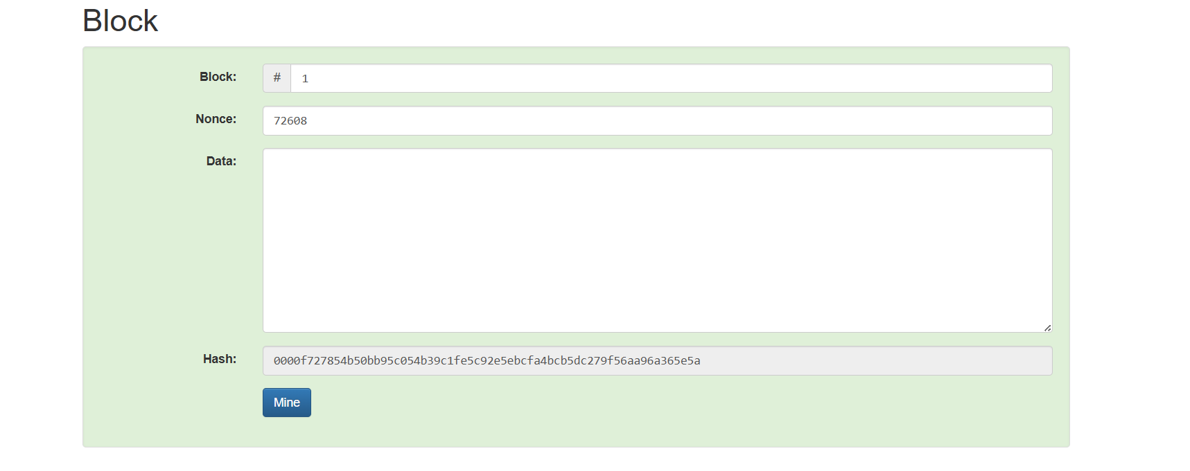

* Softwares used
- Brave Browser

- Testing Phase: Compilation of Code (error detection)

Phase: No data Modification

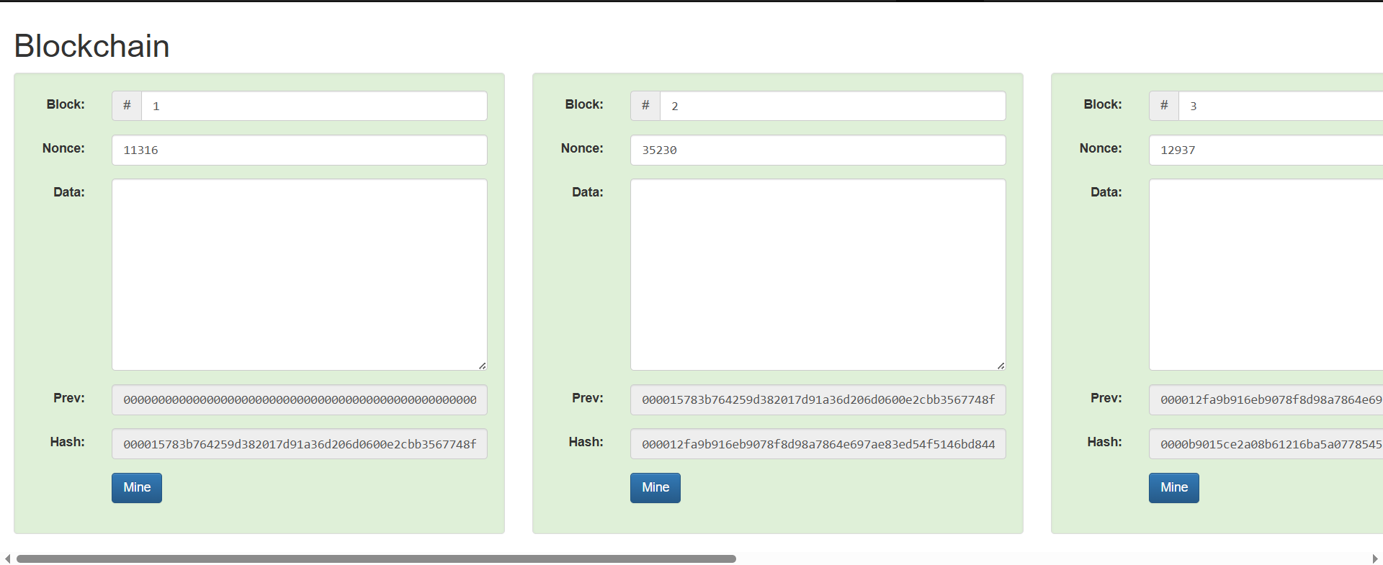

Phase: Data inserted in one block

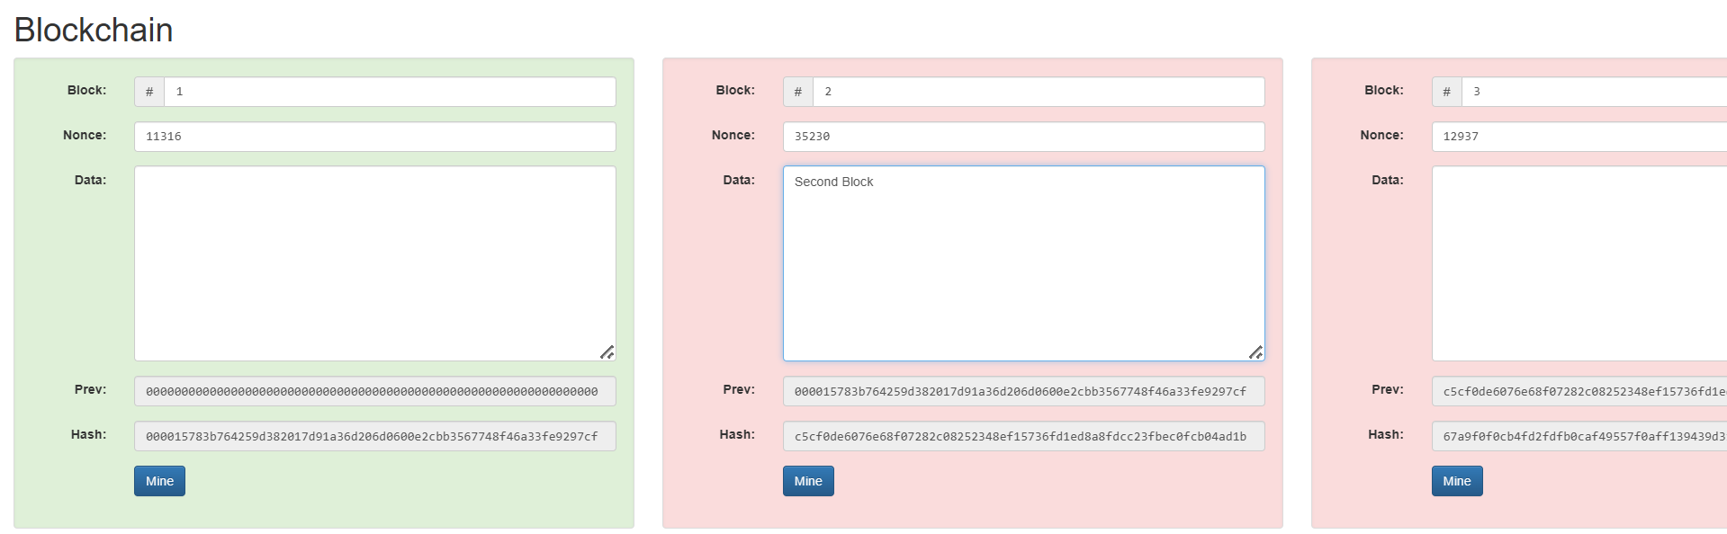

Phase: Data Inserted only in second block.
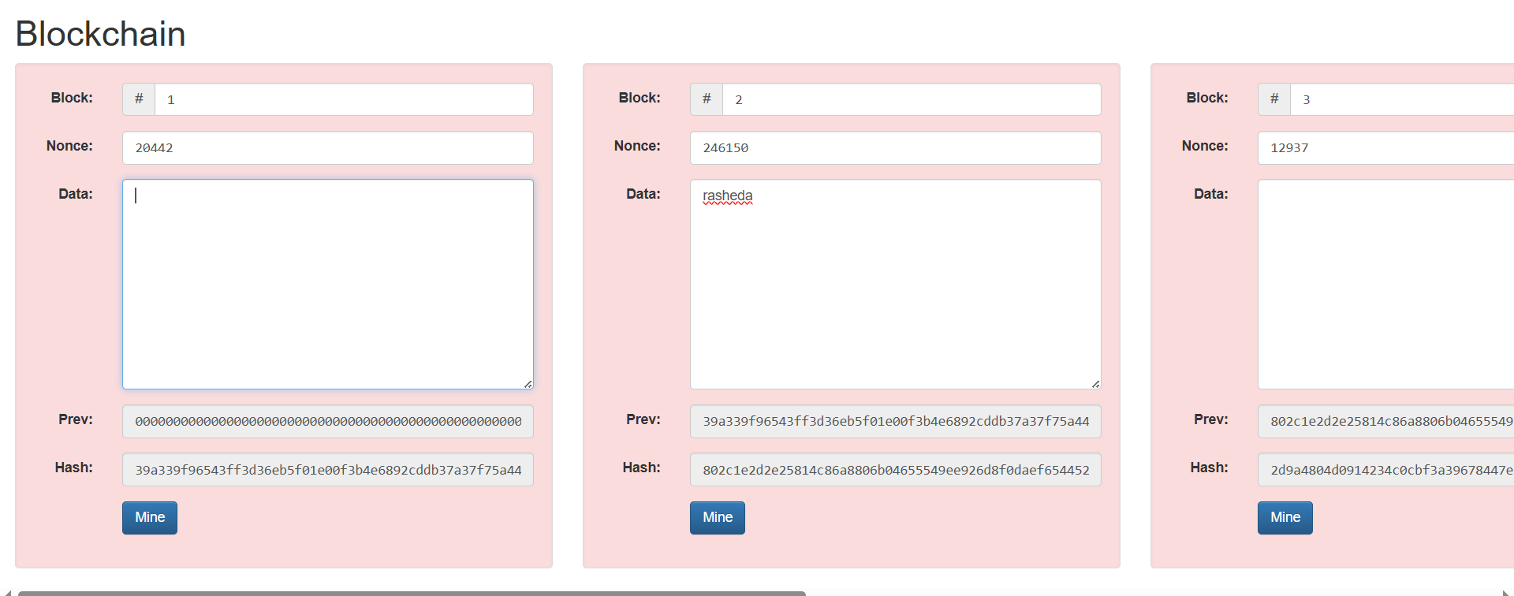

- Implementation Phase: Final Output (no error)

Implementation Phase: Final Output (no error)

- Implementation Phase: Final Output (no error)
Applied and Action Learning

* Observations
- Each block holds transaction data, a time record, and the hash of the block before it.
- The use of hashing guarantees that data remains intact and unchanged over time.
- A hash function always produces the same output for identical input, yet it’s impossible to reconstruct the original data from the hash.
- The safety of a blockchain relies heavily on the cryptographic hashing mechanism.

ASSESMENT

Rubrics
Concept | 10
Planning and Execution/  Practical Simulation/ Programming | 10
Result and Interpretation | 10
Record of Applied and Action Learning | 10
Viva | 10
Total | 50


Signature of the Student:
Signature of the Faculty:

